

Portfolio Management Strategy

Table of Contents

- Scope
- Due Diligence, Projections and Bidding Process on New Portfolio Forward Flow Opportunities
2.1 – Investment Model
2.2 – Due Diligence and Price Determination
- Contingency Collection Strategy
- Insurance Policies
4.1 – Debt Settlement Company (“DSC”) Accounts
4.1.2 – DSC Strategies
4.2 – Sales of Residual Inventory
- Performance

- - Scope
Nexa Asset Acquisitions, LLC (“NAA”) won the bid on two (2) 12-month forward flow opportunities in late 2024. NAA secured a third 12-month forward flow opportunity in September 2025. This document illustrates every aspect of overall portfolio management strategy for these three (3) monthly forward flows as listed out in the above table of contents.

2.0 – Due Diligence, Projections and Bidding Process on New Portfolio Forward Flow Opportunities
NAA was invited to bid on three 12-month forward flow opportunities with a NASDAQ-listed Fintech lender in Q4 of 2024. Specifically, those were Fintech 1, Fintech 2 and Fintech 3

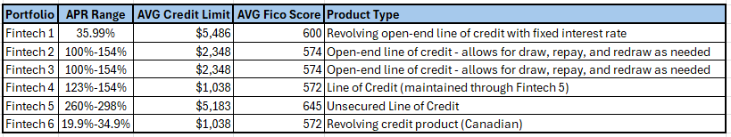

NAA was awarded the contracts on Fintech 1 and on Fintech 2:
- Fintech 1
  - 8.5% pricing
  - Volume estimated $250,000-$500,000 face value monthly
- Fintech 2
  - 6.5% pricing
  - Volume up to $5million monthly

The initial purchases at the end of December are shown below. Fintech 1 included a warehouse file of older (“aged”) accounts that were purchased at 7% price point:

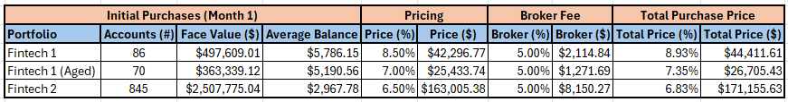

The issuer decided to hold off on selling the Fintech 3 portfolios in January 2024 and NAA was notified that it was available in August 2024.
- Fintech 3
  - 7.5% pricing
  - Volume at approximately $3million per month
NAA was awarded the contract for the Fintech 3 12-month forward flow in September 2024. The initial purchases at the end of September are shown below. Fintech 3 included a warehouse file of older (“aged”) accounts that were purchased at 7% price point:

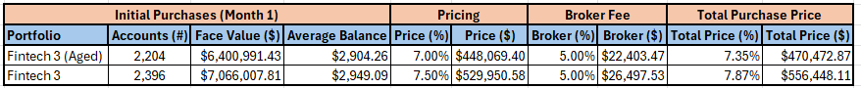

2.1 - Investment Model
- Investor capital estimated to be returned between Month 12 and Month 15.
  - Investor receives net cashflows monthly starting in Month 2.
- Total return estimated at 167% by the end of Month 36.

NAA’s used its standard 36-month Investment Model to calculate appropriate pricing based on achieving a “3X gross liquidation rate” on the purchase price. This calculation assumes
- Return of investor capital (1X)
- Cost of collections (1.37X – i.e., agency contingency fees, NAA management fees, and NAA performance fees)
- Investor return/profit (0.67X+)
This calculation is used solely for calculating projections on contingency collections and excludes potential sales of residual (non-paying) inventory or sale of DSC matches at a premium.

2.2 – Due Diligence and Price Determination
Propel Holdings provided data files prior to bidding for due diligence. They also advised the following:
- Fintech 1 accounts are sold between Day 90 and Day 120 of Delinquency. The accounts are charged off and shelved at Day 1 of Delinquency and are not worked internally nor externally at all. Therefore, upon purchase, NAA agencies are the first contact to the consumer since Day 1 of Delinquency.
- Fintech 2 accounts are sold at Day 90 of Delinquency and charged off on the sale date. Accounts are worked internally after Day 1 of Delinquency and only one (1) settlement offer is issued during that period.
- Fintech 3 accounts are sold between Day 90 and Day 120 of Delinquency. The accounts are charged off and shelved at Day 1 of Delinquency and are not worked internally nor externally at all. Therefore, upon purchase, NAA agencies are the first contact to the consumer since Day 1 of Delinquency.

NAA conducted due diligence as follows:
- Review Seller Surveys
  - Internal collection activity prior to sale
  - Settlement %’s offered if any
  - Resale allowed?
  - Legal strategy allowed?
- Perform a stratification of the provided data files:
  - Demographics
    - Inventory by state
  - FICO scores
  - Payment histories
  - % of “first payment defaults” if any
- Confirm 100% of supporting media documents will be provided upon purchase
  - Original contracts
  - Transaction Histories
- Confirm consent for contact in original contracts:
  - Consent to call cell phones
  - Consent to text message
  - Consent to send email communications
- Confirm % of verified current contact information provided
  - Address
  - Cell phone
  - Email address
- Review historical batch tracks on same or similar products from internal and external sources.
  - Agencies and debt buyers in NAA’s network of peers were able to produce historical batch tracks on Credit Fresh portfolios.
    - NAA has confirmed that agencies have achieved gross liquidation rates of 19% to 22% on Fintech 2.
    - Additionally, another debt buyer who offered to sell NAA an older Fintech 2 file (we were able to infer that they are another buyer who purchases freshly charged off Fintech 2 as NAA does), confirmed that according to their historical batch tracks they achieve gross liquidations of 21% over 3 years.
  - Utilizing the monthly liquidation rates over 36 months enables NAA to determine the threshold of pricing where NAA would then attempt to bid (and win) at a lower price point.
    - Fintech 1 – at 8.93% price point, NAA must achieve a 26.79% gross liquidation over 36 months.
    - Fintech 2 – at 6.83% price point, NAA must achieve a 20.49% gross liquidation rate over 36 months.
3.0 - Contingency Collection Strategy
- NAA onboarding process involves a thorough due diligene and vetting process, validating both compliance and past performance.
- Agencies are required to provide weekly reporting of all Key Performance Indicators (“KPIs”)
  - Agencies are shown comparative data (KPIs) of their peers .
  - NAA meets with agencies weekly to discuss competitive reporting, discuss strategy and ensure that agencies are managing to strategy competitively or adjusting strategy quickly where opportunities are identified in the reporting versus other agencies.
- Agencies are provided with target liquidation rates for current month collections as well as for building their payer base (i.e., secured postdated checks).
  - Refer to “NAA - Contingency Collections Strategy” on pages 8 thru 10.
    - Managing the agencies to the KPIs as described in this document and incentivizing them with more inventory drives performance and ensures that targets are reached.
    - Converting as many Right-Party Contacts (“RPCs”) into payers as possible and building the payer base (i.e., Secured Postdated Checks) is the key to the strategy.
4.0 – Insurance Policies
NAA refers to additional “levers” in the strategy outside of the contingency collections as its “insurance policies” because these “levers” are not included in the monthly and overall liquidation percentages on the waterfalls.

4.1 – Debt Settlement Company (“DSC”) Accounts
Upon purchasing each monthly portfolio, NAA has the portfolios scrubbed by multiple peers who specialize in working with DSCs and who have data-sharing agreements with these DSCs, enabling them to determine which consumers are enrolled with one of these companies. Initial match rates average as follows:

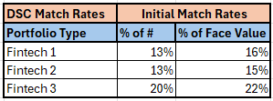

4.1.2 – DSC Strategies
Approximately 70% of consumers enrolled in a Debt Settlement Company program can be expected to complete the program.
- These payment plans are based on an average settlement amount of 50% of the balance in payments over 1 to 3 years.
- NAA has several agencies in its network who specialize in servicing these accounts as they have a separate department with agents that have established relationships with the representatives at the DSCs.
- These accounts can be sold at a premium, anywhere from 12% to 15%.
- As the portfolio ages, additional consumers will enroll in the program (hence, increasing “match rates”)
  - Prior to joining Peter at GDM/Nexa, Matt was the COO at Axiom Acquisition Ventures (“AAV”), a debt buyer that focuses specifically on purchasing and servicing DSC accounts. Matt recalled (and confirmed with his contacts there) that AAV was purchasing monthly DSC matches from another debt buyer that were 12 months past charge-off or older. The match rates on these portfolios are 23% to 27%.
  - NAA anticipates additional DSC matches as the portfolios age, building in additional “insurance” on returns.

4.2 – Sale of Residual Inventory
NAA plans to sell residual inventory after completing the contingency collection cycle on each portfolio.
- At the outset when initial projections were calculated, sales were anticipated to be conducted between Months 18 and Month 24, allowing for four (4) agency placement periods (Primary, Secondary, Tertiary and Quad).
- Estimated residual inventory would be the remaining inventory from the original face value of each portfolio, excluding:
  - The total face value of the paying inventory
    - Example – Fintech 2 calls for a 20.49% gross liquidation rate to achieve a “3X” (as described above in section 2.2). We can anticipate that approximately 21% of the original face value can be subtracted from the estimated residual inventory.
  - A small percentage of accounts will be rendered “uncollectable” – NAA anticipates an average of 12% in this category:
    - Bankruptcy
      - Some of these can be sold, often as soon as they are identified as bankruptcy so as to allow the buyer (often a company that specializes in collecting on bankruptcy accounts) to be included in the bankruptcy filing for Chapter 13 (reorganization for repayment with protection from creditors).
    - Deceased
    - Fraud/Dispute
    - Cease and Desist
- NAA will negotiate the best price possible for the resale of the remaining accounts (approximately 60%-65%:
  - DSC matches can be sold at a premium.
  - Non-DSC accounts will still be attractive to potential buyers because:
    - There is only one debt buyer (NAA) in the chain of title along with the original creditor.
    - Accounts were purchased at charge-off, so all accounts will still be “In Stat” (within Statute of Limitations) with plenty of time for the new buyer to execute their collection strategy through multiple agency placements.
    - Many consumers that have not paid within the first 18 to 24 months will have had enough time to correct their situation and begin paying off debt.
- Sale proceeds are NOT calculated in the waterfall projections to reach the 3X gross liquidation. These accounts serve as the “Insurance Policy” for NAA in the event of unexpected circumstances (Economy downturns, natural disasters, pandemics, etc.)

5.0 – Performance
NAA manages strategy to Investor Returns. The Portfolio Trending report in PowerBI (see screenshot below) is updated weekly with Agency Weekly Reporting provided every Monday by 12noon EST, representing collections through the end of business on the previous Friday.
- This shows how we are trending with posted cash plus postdates through Month 12, and posted cash plus postdates through Month 36 respectively, as we target 100% of investor capital returned in 12-15 months, and an overall return of 167%+ by Month 36.
- Portfolios 1410 and 1402 should have 100% of investor capital returned within the next 2-3 months.
- Portfolios 1501, 1502 and 1503 should return 100% of investor within the next 5 months.
- All portfolios are trending well,

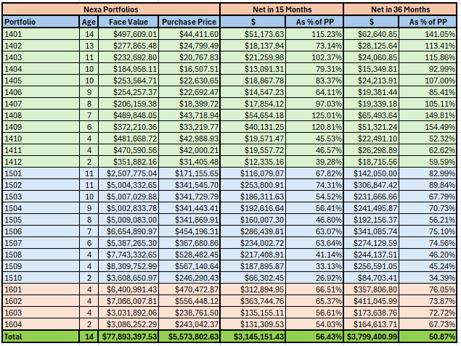
Contingency Collection Strategy

Contingency Collection Strategy is based on five Key Performance Indicators (KPIs). NAA’s agencies must not only set expectations but also consistently and effectively manage their agents to ensure that strategy is being executed for maximal performance:
- Letter Strategy
  - Initial Notice Letter is required by law within 3 to 5 days of account placement with agency.
  - Emails cost 1-cent per, offsetting the costs of paper letters and postage.
- Attempt Rate
  - The Consumer Financial Protection Bureau (CFPB) Regulation F, established in November 2022, dictates that a collection agency may only make 7 attempts in a 7-day period, including calls, emails, and texts.
  - Dialing and/or texting the best numbers (i.e., verified cell phones) is imperative.
- Contact Rate – Number of RPCs (Right-Party Contacts) divided by number of Attempts (Calls)
  - If the appropriate number of attempts are being made, the result should be a Contact Rate of 10%-15%
- Conversion Rate – Converting RPCs to Promises and Payers
  - 50% of consumers should commit to some type of arrangement (Promise To Pay)
  - 50% of the consumers who promise to pay will actually secure, and follow through with, their payment arrangements.
- Payment Arrangements
  - Effective negotiations and follow-up will result in an NSF (insufficient funds) and Broken Promise rate of 5% or less (anything higher is unacceptable)
  - Payer Base and Monthly Liquidation Rates should increase accordingly, as Down Payments, Lump-Sum Settlement Payments and Postdated Payment Arrangements are consistently secured over time.

Letters – Strategy for regulatory compliance and for performance
- Initial Dunn upon placement
- Second Notice after 30 to 45 days from placement
  - Settlement Offer is often employed in the second notice letter.
- Letters sent monthly during the entire placement period.
- Inbound Call KPI Tracking – RPCs, Conversions, Payment Arrangements

Attempts – Calls, Emails, Texts
- Maximizing Penetration
  - Collectors dialing 25 to 30 phones per hour to penetrate as much of the inventory as possible.
- Leaving voicemails
  - Limited allowed attempts (per CFPB Regulation F)
- Sending Emails and Texts
  - Inbound Call KPI Tracking – RPCs, Conversions, Payment Arrangements
- Permission to call back
  - Negates CFPB Regulation F requirements on attempts and enables follow-up with consumers as needed until a payment arrangement is secured.

RPCs – Right Party Contacts
- Maximizing penetration
  - Collectors should be dialing 20-30 phone calls per hour UNLESS they are contacting an appropriate number of consumers, in which case they will be on the phone negotiating and securing payments.
- Dialing the correct phones
  - Everyone has cell phones. With CFPB Regulation F attempt limitations, cell phones should be verified via trusted skip tracing tools and should be called as the priority phone number on the file.
- Varying call times
  - Ensures contact the consumer at the Best Time to Reach
- Consistent follow-up
  - If a consumer or third-party advises of a Best Time to Reach the consumer, collectors MUST call back at that time.

Conversions – Secured Payers and Unsecured Promises
- Effective negotiations
  - Treating the consumer with dignity and respect
    - Building rapport
    - Showing empathy
  - Understanding the situation
    - Quickly determining the consumer’s circumstances and reason(s) for delinquency
  - Giving the consumer a sense of control
    - Offering multiple payment options based on consumer situation
      - Balance in Full in one payment
      - Down Payment followed by monthly payments
      - Settlement in one payment
      - Multi-Part settlement
        - Must be justified by consumer circumstances and quantified with money source(s), etc.
        - Must be a higher % than the One Payment Settlement (to incentivize the one-time payment as a more lucrative option to the consumer)
  - Showing a path forward
    - Pitching the benefits of prioritizing the resolution of this particular debt
    - Securing a payment arrangement that the consumer agrees with and can afford.
- One Contact Resolution
  - Analytics have shown that if a consumer is contacted and payment arrangements are not discussed, there is only a 6% chance of ever contacting that consumer again.
- Second-Voice
  - The collector must transfer the call to a supervisor if a payment arrangement is not committed to or secured on the call.

Payment Arrangements
- Payment Rules
  - Duration (i.e., number of payments/months to resolve)
    - Collectors should be pitching a larger down payment if securing a monthly payment arrangement.
  - Pitching tax refunds year-round
    - Collectors should not secure monthly payments of the same amount through the following tax season without asking about a tax refund and discussing a higher payment at tax time with that refund.
  - Average Payment Size
    - This is a Key Indicator of effective negotiations and adherence to payment rules.

Matt Dion
Chief Operating Officer/Chief Compliance Officer | Nexa Asset Acquisitions, LLC
mdion@nexaportfoliostrategies.com

DISCLAIMER: Past performance may not be indicative of future results. Therefore, no current or prospective client should assume that future performance of any specific investment or investment strategy (including the investments and/or investment strategies undertaken by Nexa Asset Acquisitions, LLC) made reference to directly or indirectly by Nexa Asset Acquisitions, LLC in its website, or indirectly via a link to an unaffiliated third-party website, will be profitable or equal the corresponding indicated performance level(s). Different types of investments involve varying degrees of risk, and there can be no assurance that any specific investment will either be suitable or profitable for a client or prospective client’s investment portfolio. Historical performance results for investment indices and/or categories generally do not reflect the deduction of transaction and/or custodial charges, the deduction of an investment management fee, nor the impact of taxes, the incurrence of which would have the effect of decreasing historical performance results.
Please remember that different types of investments involve varying degrees of risk, and there can be no assurance that the future of any specific investment or investment strategy (including those undertaken by Nexa Asset Acqusitions, LLC) will be profitable or equal any historical performance level(s).

